MAKE TO INNOVATE - PROJECT EXECUTIVE SUMMARY

Boeing Electric Flight

Alexander Britton

PROJECT INFORMATION

Project Name | Boeing Electric Flight | # semesters in service | 12
Project Classification | Industrial | Budget Requested | $21.78
Project Student Leader | Alexander Britton | Budget Approved | $0
Project Member Size | 17 | Budget Spent | $0

The project has 3 teams. The team leaders are: Robert Schorr, Jason Kelly, and Tyler Mains. We have been operating for 6 years. The stakeholders for the Project are:M2I, Boeing.
ORGANIZATION CHART
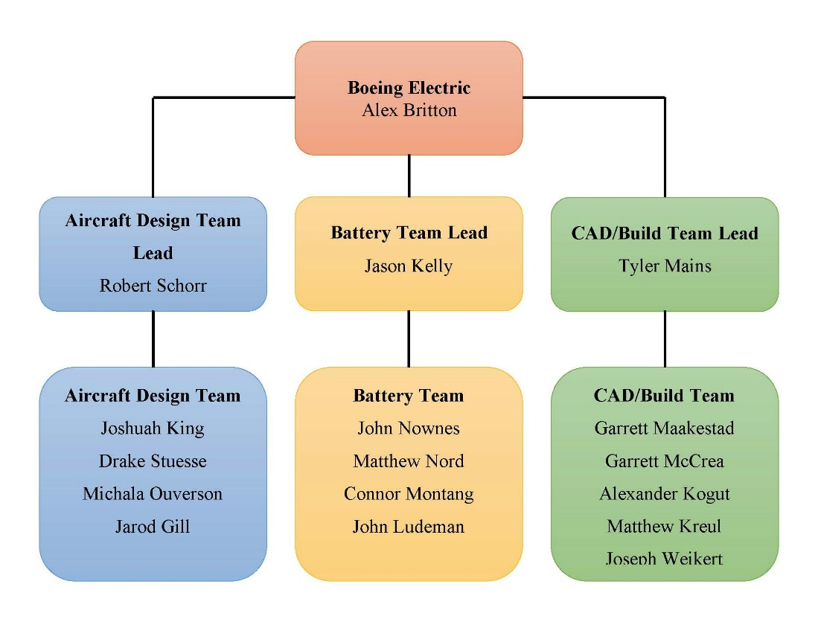

PROJECT MISSION STATEMENT
The overall mission for the Boeing Electric Flight project is to explore the viability of an all-electric commercial aircraft designed to replace a Boeing-737-like aircraft with comparable cruise speed, range and passenger capacity. In exploring the viability, the project seeks to develop a lithium air battery as well as explore and optimize non-conventional wing designs for testing.

PROJECT GOALS

The Aircraft Design team seeks to develop an understanding of the feasibility of an aircraft that is all electric and of the scale of the Boeing 737. We seek to do this by the utilization of non-conventional wing designs, the development of systems that are capable of supporting the needs of batteries and the understanding of the emerging research that may support an aircraft of this type. We are conducting this through aerodynamic research on a box and high aspect ratio wing designs, the research, and development of a cooling system for our batteries, and investigating alternative propulsion methods.

The CAD/Build team seeks to explore the schematics of control surfaces and electronics of RC aircraft. The team purchased an RC plane in order to investigate the electronics integration and place the lithium-sulfur battery into a stable flight system when we test it. We researched the best possible foam for the new wing designs to test on the RC plane. After ordering the foam, we will cut out the wing designs created from the aircraft design team and test them on the RC plane in the Wind tunnel.

The Battery team seeks to develop a safety plan that outlines both components and procedures that would be unique to a battery-powered electric aircraft. In addition to the safety plan, the Battery team also seeks to design a three-dimensional digital model of the compartments that will be used to store the batteries in the aircraft during flight.

PROJECT DELIVERABLES

The Aircraft Design team anticipates the analysis of the micromechanics of the wing with numerical data provided from ANSYS. Then it will be imported into the ABACUS software so the analysis of the ply layers of the composite could be performed and the ply number, as well as orientation, could be designed.

The CAD/Build team expects to cut the Swept and Box wings out of the new foam and attach them to the RC plane. Flight data will be recorded for these two wing types. We cannot test the High Aspect Ratio wings on the RC plane, as they are two big to be supported by the RC plane.

The Battery team will deliver a safety plan that will detail specific processes and components that are solutions to unique problems presented by a battery-powered aircraft. The Battery team will also deliver a virtual model of the battery compartment. This model will be designed using Solidworks.

PRESENTATION SUMMARY

This semester, our milestones for the Aircraft Design team are to complete preliminary research of an advanced cooling system and to conduct finite element analysis on our designed wings including micromechanics numbers gained from the structure shown in Figure 1. The Battery team is developing a safety plan which will describe the necessary actions and components that are needed to solve unique issues that may occur in an aircraft that is powered by batteries. The CAD/Build Team will be completing the initial testing of the RC plane while researching potential foam to be purchased to use to build our wings, and then conduct final testing of our RC plane after our wing designs have been built and attached to the plane.

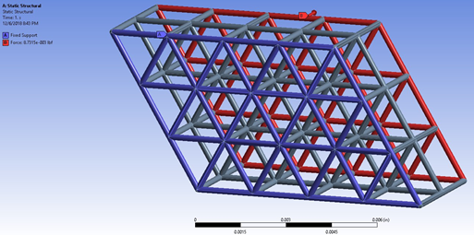
Figure 1: Structural Analysis

The Aircraft Design team is currently in the process of researching an advanced cooling system for our batteries. This design would expel our excess heat out of our wings, with the hope that this will make electric flight more feasible by potentially improving the lift of a commercial aircraft. The Aircraft Design team is also in the process of looking into the optimization of closed wings (see Figure 2) and truss-braced wings (may evolve out of the high aspect ratio wing, as shown in Figure 3), which are non-conventional wing designs. We are using CFD (computational fluid dynamics) simulations that utilize the RANS (Reynolds-Averaged Navier-Stokes) equations in order to optimize both these new wings and our previously designed wings. A turbulence model is also being created in STAR-CCM+ for these wings, as well as structural modeling of these wings using FEA (finite element analysis) in ABAQUS. After these tasks have been completed, and many test iterations have been run, the results from the simulations of the wings will be compared to each other, and a final wing design will be selected. Later, we will manufacture our optimal wing and conduct additional analysis by subjecting the wing to wind tunnel testing.
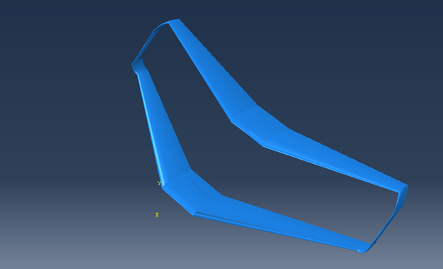
Figure 2: Closed Wing
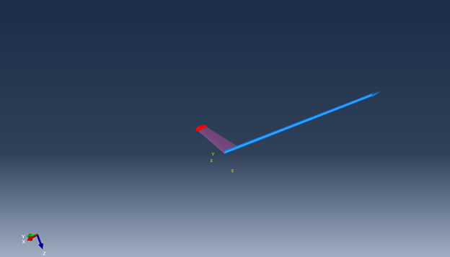
Figure 3:High Aspect Ratio Wing

The Battery team has completed an outline for topics that must be discussed in our safety plan. It was divided into two topics, with additional subtopics for each topic. The first topic that is discussed is the emergency landing procedures. The main issues that we are looking into with regards to an emergency landing are the constant weight of the aircraft throughout the entire flight, as well as any special requirements or precautions that must be taken by airport fire and rescue teams. The other topic is battery redundancy. We are currently looking into the best way for us to isolate different batteries within similar systems, as this will be essential to help us isolate any fires and prevent it from spreading to other parts of the plane. The team has recently started researching how a variety of different cargo carriers transport cargo within the cargo hold of the aircraft. This information will be used when we look at a system for batteries to be easily removed and replaced after each flight. This will hopefully reduce layover time of commercial aircraft by replacing the drained batteries with ones that are fully charged. The batteries that were just in the plane would then be recharged for use in a future flight. A virtual model will then be created in Solidworks with this goal in mind.

The CAD/Build team has finished their research into the new foam and are currently working on completing the ordering process for the foam that had been identified as the best option for us. We started to research this foam due to the fact that our current blue foam is too dense, with the average density determined to be approximately 171.7 kg/m³ from testing. Since the current blue foam is too dense, the wings are too heavy for our RC plane to be able to fly. When researching the new foam that we intend to purchase, we have looked into many factors and properties of the foam. These include the foam’s density, the firmness/deflection of the foam, the tensile strength, the R-value of the foam, the temperature range at which the foam starts to melt, the price, and the manufacturability of the foam. Additionally, we are currently finishing up our initial testing of the RC plane. Various tests include weighing the RC plane with and without the wings, measuring the voltage and current from the plane wiring with a voltmeter, and determining the thrust that the RC plane will produce. After the foam has been purchased, we will then have our designs sent to the lab technicians to be cut out. Once the wing designs have been cut out, we will attach the wings to the RC plane and collect flight data for both the Swept and Box wings.

Currently, there is one task at risk of being off track, and that is the ordering of the foam. Subsequently, our future tasks that depend on the new foam are also at risk of being off track. These tasks include the building of the wings and our tasks that are associated with testing our RC plane with the new wings attached to it. All other tasks are on track so far.

Obtaining our battery currently constraints our design. We are currently limited when it comes to facilities that we can build our battery in, and we are currently searching for other facilities that would allow us to build our battery. Additionally, we have also looked at the possibility of potentially buying a lithium-sulfur battery. Upon research, we have found that this is something that currently is not possible due to the cost of these batteries.

Long term risks include battery construction and model aircraft flight. We are currently developing our battery safety plan, as well as our RC plane testing procedure.

