Make to Innovate – Midterm Executive Summary

CySat

Mackenzie Kilcoin

Project Information:
Project Name | CySat | # semesters in service | 8
Project Classification | Research, Service | Budget Requested | $16,650.00
Project Student Leader | Mackenzie Kilcoin | Budget Approved | $10,150.00
Project Member Size | 16 | Budget Spent | $0.00

The CySat project is compromised of 16 official members with members varying from aerospace, computer, and mechanical engineering disciplines. The project began in mid-2003 when a group of students first constructed CyCADET and flew it on NASA’s Weightless Wonder in early 2004. Since then, the project evolved to working on a 1U cube satellite. A cube satellite is a 10 x 10 x 10 cm³ structure that encapsulates all components of a spacecraft. Cube satellites typically operate in low Earth orbit (LEO), but they can operate in any region of space with the right equipment. In early 2016, the first CubeSat Launch Initiative (CSLI) form was submitted to NASA and rejected. The team then decided to transition to a 3U concept and the next CSLI was accepted in early 2017. Since then, CySat’s purpose is to design, fabricate, and operate a 3U cube satellite in LEO by late 2019. During spring 2019, CySat is comprised of three teams, which include communications and regulations, headed by Sam Ruhlin; structures and testing, headed by Mo Reza; and electronics, headed by Josh Gilmore. Current stakeholders include NASA’s Launch Services Provider (LSP), Iowa Space Grant Consortium, Iowa State University’s Aerospace and Computer Engineering departments, and the Make to Innovate program.
Project Organizational Chart:
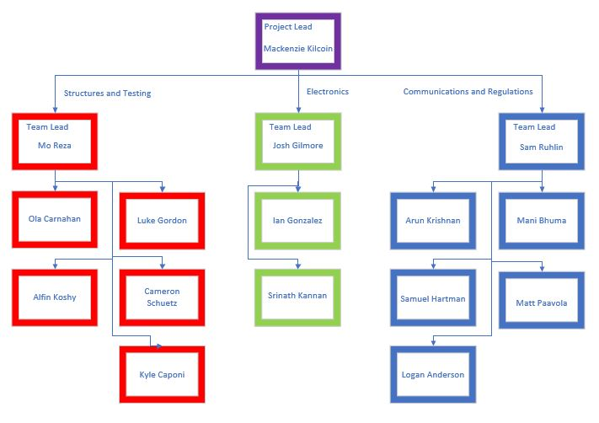
Project Mission Statement:
CySat aims to launch a 3U cube satellite into low earth orbit by April 2019. The project itself aims to get students to apply skills in a real-world aeronautical mission and demonstrate technology for use in future missions.
Project Goals:
The project has three primary goals and a multitude of secondary goals. First, CySat aims to teach students the process and application of designing a spacecraft. This prepares students for industry or other professional projects that require solving new problems based on researched knowledge. Second, CySat-I serves as a technology demonstration mission; modeled from Matt Nelson’s thesis, the satellite employs the use of a radiometer to detect changes in temperature and determine soil moisture content on Earth. This will provide adequate evidence that this type of payload could be used in a variety of future missions, including detection of other materials in near-Earth objects. Finally, CySat-I is a landmark project for Iowa State University and the Department of Aerospace Engineering by providing the first object to orbit Earth from the university and one of the first spacecrafts from the state of Iowa.
Project Deliverables:
By the end of the spring 2019 semester, CySat will have a finished 3U cubesat to hand off to the launch integrator. Along with this, all testing reports and required licenses will be complete.
Presentation Summary:
CySat-I is currently in the final stages of integration to prepare for the final handoff to the launch integrator. Three teams of students are finishing up this work and have split up the various subsystems of the satellite into their respective branches to delegate work. The presentation will focus on current issues at hand per each of the following subsystems.
The structures team is responsible for developing the subsystem that mechanically supports all the other subsystems and meets the requirements of the deployer and the International Space Station. The team's goal is to build a flight-ready structure/chassis ready for the integration by the end of the semester. The structures team works with the payload, electrical and communications teams to ensure solar arrays are fabricated to the needs of CySat-I's power budget and all modules are successfully integrated. This semester, the team is finalizing the design to be followed by both vibration and static structural analysis of the satellite prior to final fabrication to ensure the structure can manage all forces involved in launch and space environments. Technical advisor Brian Kempa is assisting the team members with this mesh and analysis of the model. After a successful analysis, the structure will be manufactured at Howe Welding and Metal Fabrication. Upon the fabrication of the parts for CySat-I, the rails and standoffs will be sent for hard anodization at Liberty Anodizing in West Liberty, Iowa. Once the structure has been hard anodized, it will be assembled as part of the integration of all the systems.
The electronics team has been tasked with fabricating and integrating the power and payload systems of CySat-I. CySat-I’s payload consists of a radiometer, made from a software-defined radio, that will be used to measure moisture in Earth’s soil. To ensure the functionality and effectiveness of the payload’s software, the electronics team has been working with a team of computer engineering seniors, led by Professor Phillip Jones, assisting the project for their senior design project. The power system of the satellite consists of a set of solar panels that will be integrated into the sides of CySat-I’s structural frame as well as the various circuit boards, integrated inside the frame, that will manage the power distribution throughout the satellite. By the end of the semester, the electronic systems will be fully integrated into the satellite and ready to be launched into orbit.
The communications and regulations team of CySat-I is responsible for both ensuring that the members on the ground can communicate with the satellite through the assembly of a ground station and the integration and testing of a commercial off the shelf (COTS) radio as well completing all forms required by regulatory bodies for the satellite to legally enter space. The team has been working with advisors and students from other M2I projects to guarantee the timely construction of the ground station hardware as well as installation of any necessary software; all of which should be completely done by the weeks leading up to the end of this semester. Communications also aims to have the radio integrated and tested for compatibility with the ground station by the end of the semester.

