Make to Innovate – Midterm Executive Summary

CySat

Mackenzie Kilcoin

Project Information:
Project Name | CySat | # semesters in service | 8
Project Classification | Research, Service | Budget Requested | $23,486.00
Project Student Leader | Mackenzie Kilcoin | Budget Approved | $19,394.00
Project Member Size | 16 | Budget Spent | $16,944.00

Project Summary:
The CySat project is compromised of 16 official members with members varying from aerospace, computer, and mechanical engineering disciplines. CySat’s purpose is to design, fabricate, and operate a 3U cube satellite in LEO by late 2019. CySat is comprised of three teams, which include communications and regulations, headed by Sam Ruhlin; structures and testing, headed by Mo Reza; and electronics, headed by Josh Gilmore. Current stakeholders include NASA’s Launch Services Provider (LSP), Iowa Space Grant Consortium, Iowa State University’s Aerospace and Computer Engineering departments, and the Make to Innovate program.

Structures is responsible for developing the subsystem that mechanically supports all the other subsystems and meets the requirements of the deployer and the ISS. The team's goal is to build a flight-ready structure/chassis ready for integration by the end of the semester or mid-summer. They work with the electronics, communication and payload teams to ensure the solid model depicts accurate placements of the components like the SDR board, solar arrays, ADCS, and EPS systems. The crucial tasks that the structure team performs include making changes in the model to make sure other co-dependent components coordinate accordingly with new changes and updating the Safety Data Template weekly to provide NANORACKS with most recent updates.

CySat’s communications and regulations team is responsible for the testing and integration of both the radio and ground station. This semester, they ran tests on the ground station including pinging the ISS with ISU’s ground station. Additionally, the communications team is responsible for organizing the task list of CySat’s ADCS system into an easily readable format for the payload team to use when programming it. In the future, the communications team will manage all communication between Iowa State’s ground station and the satellite for acquisition of data and initiating active procedures in the satellite.

The electronics team primarily worked on the power systems of CySat-1, including solar arrays and the EPS. For the EPS, the electronics team lead worked with Matthew Nelson and EnduroSat in order to get the EPS ready to interface with other systems. Additionally, the solar array designs were redesigned to be compatible with the rest of CySat-1. To complete this task, the team utilized Ki-CAD to create schematics to ensure all physical components of the arrays were placed correctly onto the PCB without conflicting with other components.

Project Organizational Chart:
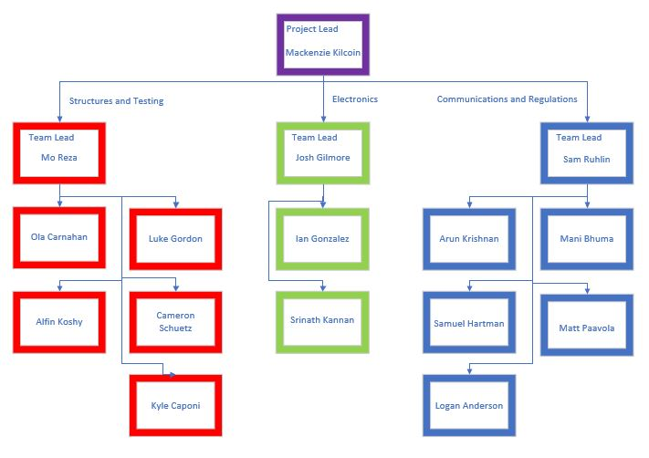
Project Mission Statement:
CySat aims to launch a 3U cube satellite into low earth orbit by mid 2019. The project itself aims to get students to apply skills in a real-world aeronautical mission and demonstrate technology for use in future missions.

Project Goals:
The project has three primary goals and a multitude of secondary goals. First, CySat aims to teach students the process and application of designing a spacecraft. This prepares students for industry or other professional projects that require solving new problems based on researched knowledge. Second, CySat-I serves as a technology demonstration mission; modeled from Matt Nelson’s thesis, the satellite employs the use of a radiometer to detect changes in temperature and determine soil moisture content on Earth. This will provide adequate evidence that this type of payload could be used in a variety of future missions, including detection of other materials in near-Earth objects. Finally, CySat-I is a landmark project for Iowa State University and the Department of Aerospace Engineering by providing the first object to orbit Earth from the university and one of the first spacecrafts from the state of Iowa.

Project Deliverables:
By the end of the spring 2019 semester, CySat will have a finished 3U cubesat to hand off to the launch integrator. Along with this, all testing reports and required licenses will be complete.

Currently, CySat has all hardware in house and is working on assembly and integration. Likewise, all required licenses were obtained this semester and have been sent to the launch integrator. Testing will take place in late June prior to handoff.

Presentation Summary:
CySat-I is currently in the final stages of integration to prepare for handoff to the launch integrator. Students are finishing up this work and have split up the various subsystems of the satellite into their respective branches to delegate work. The presentation will focus on current issues at hand per each of the following subsystems.

The structures team successfully ran several vibration tests to justify the strength of the structure. Based on that, parts were manufactured at Howe Welding and Metal Fabrication and now present in the lab. Fabricated parts of the exterior structure (touching the deployer) will be sent to Liberty Anodizing for hard anodization. Some of the brackets are still in the process of manufacturing but will soon be finished. The team has been in contact with University of Michigan with the help of Dr. Lee in order to set an appointment for a flight readiness vibration test. Screws, spacers, bolts and other necessary parts from structural perspectives have been ordered. The structure team played a big role on setting up a clean, anti-static environment to handle sensitive electrical components. As of now, the structures team in on track and confident about delivering the structure on time.

The communication team’s milestones consist of making the ground station fully operational, testing and integrating radio hardware, and assisting the payload team with the ADCS. Of these tasks, only the radio system is at risk due to it not arriving until very recently, as well as the delayed integration of other parts. Our team will be using a commercial off the shelf (COTS) radio purchased from EnduroSat due to a lack of technical knowledge and simplicity. Our ground station will track the satellite from data given from the US Air Force. The biggest constraint comes from the limited power produced by CySat’s solar cells, which limits the radio to a transmission rate of 9600 baud. Aside from this, most other constraints are set by regulatory bodies such as NOAA.

The electronics team faced several challenges to ensure proper functionality of the PCBs. One such challenge was picking out diodes for the solar arrays. For the diodes to work with the arrays and prevent short-circuiting of the solar cells, the team analyzed data sheets to make a proper decision and chose the Toshiba CUS08F30 diodes. Another challenge was ensuring electronic components fit properly into the stack. To overcome space constraints, the team noted dimensions of items on PCBs, pins, and wires. Per each issue, meetings were set up with the conflicting subsystem’s team to iron out a conclusion.

Moving Forward:
Integrating a satellite, especially for a first-time group, is far from a rudimentary task and required more time and fiscal costs than predicted. In May, the team will finish integrating the satellite and prepare for a flight readiness vibration test in late June. Beyond this, a hardware freeze will take place and prepare for handoff to the launch integrator. CySat-I will fly on the NG-12 mission on October 19th, 2019, as the team will prepare for the next mission. Next semester, CySat members will use knowledge gained from the first satellite to get the best start possible on future endeavors, which are currently unknown.

