MAKE TO INNOVATE - PROJECT EXECUTIVE SUMMARY

Boeing Electric Flight

Alexander Britton

PROJECT INFORMATION

Project Name | Boeing Electric Flight | # semesters in service | 12
Project Classification | Industrial | Budget Requested | $21.78
Project Student Leader | Alexander Britton | Budget Approved | $0
Project Member Size | 17 | Budget Spent | $0

The project has 3 teams. The team leaders are: Robert Schorr, Jason Kelly, and Tyler Mains. We have been operating for 6 years. The stakeholders for the Project are: M2I and Boeing.
ORGANIZATION CHART
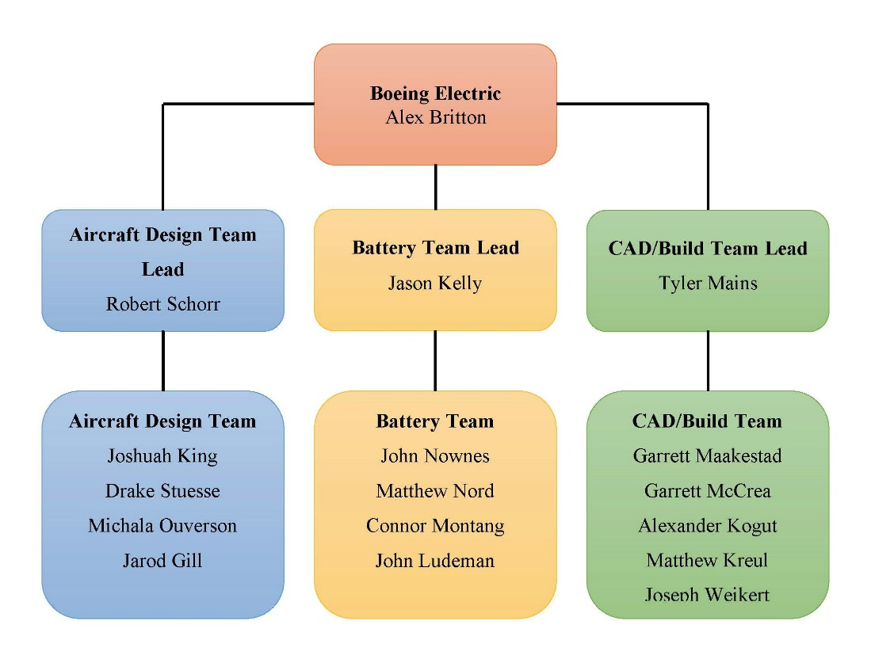

PROJECT MISSION STATEMENT
The overall mission for the Boeing Electric Flight project is to explore the viability of an all-electric commercial aircraft designed to replace a Boeing-737-like aircraft with comparable cruise speed, range and passenger capacity. In exploring the viability, the project seeks to develop a lithium air battery as well as explore and optimize non-conventional wing designs for testing.

PROJECT GOALS
The Aircraft Design team seeks to develop an understanding of the feasibility of an aircraft that is all electric and of the scale of the Boeing 737. We seek to do this by developing systems capable of supporting battery needs, utilizing wing designs considered to be non-conventional, and by looking at emerging research that may help support an aircraft of this type. We are conducting this by researching and developing an advanced cooling system for our batteries, aerodynamic research on box and high aspect ratio wing designs, and investigating alternative propulsion methods.

The CAD/Build team seeks to explore the schematics of control surfaces and electronics of an RC aircraft. The team purchased an RC plane in order to investigate the electronics integration and place the battery into a stable flight system when we test it. Our other goals were to cut out and assemble the swept wing and box wings, and to conduct wind tunnel testing. Unfortunately, we were not able to conduct wind tunnel testing due to hardware issues. We wanted to get the box wings cut out also but ran out of time. The box wing assembly and wind tunnel testing will start at the beginning of next semester.

The Battery team seeks to develop a safety plan that outlines both components and procedures that would be unique to a battery-powered electric aircraft. In addition to the safety plan, the Battery team also seeks to design a three-dimensional digital model of the compartment system used to store the batteries on the aircraft during flight. Special considerations will be taken in regard to the methods used for transferring and replacing the batteries during the layover of every flight.

PROJECT DELIVERABLES
The Aircraft Design team will deliver an analysis of the micromechanics of the wing from numerical data that has been generated by ANSYS. This analysis was then input into the ABACUS software to analyze the ply layers of the composite. This was used to design the ply number, as well as the orientation.

The CAD/Build team will deliver the swept wing cut out of blue foam, which was then attached to the RC plane. We were not able to cut out the box wing due to time constraint but will be the first thing done next semester. Unfortunately, we were not able to conduct the wind tunnel test due to hardware complications. Accommodations are already underway to conduct the test early next semester.

The Battery team will deliver a safety plan that will detail specific processes and components that are solutions to unique problems presented by a battery-powered aircraft. The Battery team will also deliver a virtual model of the battery compartment, as well as multiple methods of replacing the battery compartments in-between flights. These models will be designed using SolidWorks.

PROJECT SUMMARY
The Aircraft Design team’s milestones were to conduct preliminary research of an advanced cooling system and to conduct finite element analysis on our designed wings. The Battery team developed a safety plan describing necessary procedures and materials for solving issues in a battery powered aircraft. The CAD/Build Team conducted initial RC plane tests and researched materials to use for manufacturing our wings and had planned on conducting wind tunnel testing after building and attaching our wings to the plane.

The Aircraft Design team conducted preliminary research on an advanced cooling system for our batteries. This design would expel excess heat out of our wings, with the hope that this would improve lift on a commercial aircraft. The potential usage of distributed electric propulsion was evaluated, as well as a propulsion system using ionic wind. The team also looked at optimizing our non-conventional designs, which are the closed (Figure 1) and truss-braced wings. To optimize both these wings and our previous designs, CFD simulations utilizing the RANS (Reynolds-Averaged Navier-Stokes) equations were used. STAR-CCM+ was then used to model the turbulence for these wings, and FEA in ABACUS was used to provide a structural model.
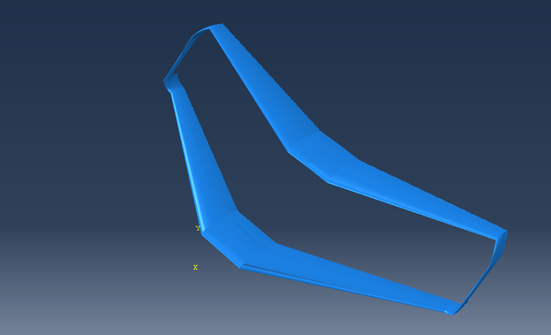
Figure 1: Closed Wing
The Battery team has completed an outline of topics in our safety plan. The two main topics of the safety plan are emergency landing procedures and battery redundancy. Under emergency landing, issues related to the landing weight of the aircraft were researched, as well as precautions that must be taken by first responders. Under battery redundancy, the team researched how to draw power from specific batteries, and how to handle batteries in-between flights. Additionally, we researched and designed methods of storing and transporting batteries in the aircraft using SolidWorks. The two systems that we have worked on involve a belt-feed type loading system, as well as a cargo pallet type loading system (Figure 2). We are currently still evaluating the pros and cons of each system, but we have designed both systems.
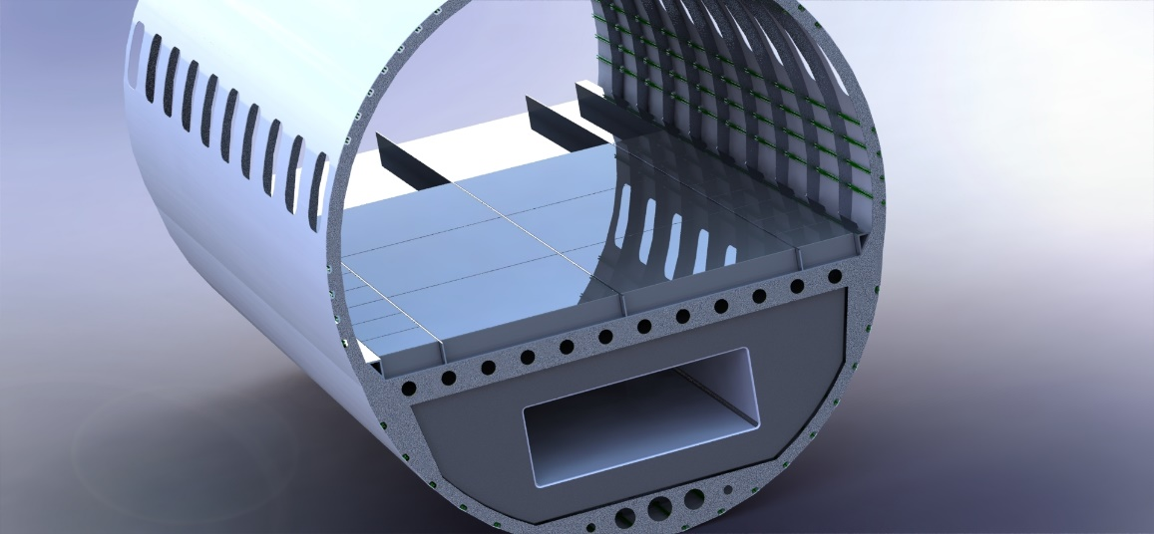
Figure 2: Cargo Pallet Loading System

The CAD/Build team has finished their research into the new foam and decided to use the blue foam for testing purposes. The swept wing has been cut out and assembled (Figure 3). The box wing will be cut out early next semester. The team researched various manufacturing techniques and materials for future wing designs. We learned the program LabVIEW for the wind tunnel sensors, which will be used when conducting future wind tunnel testing.
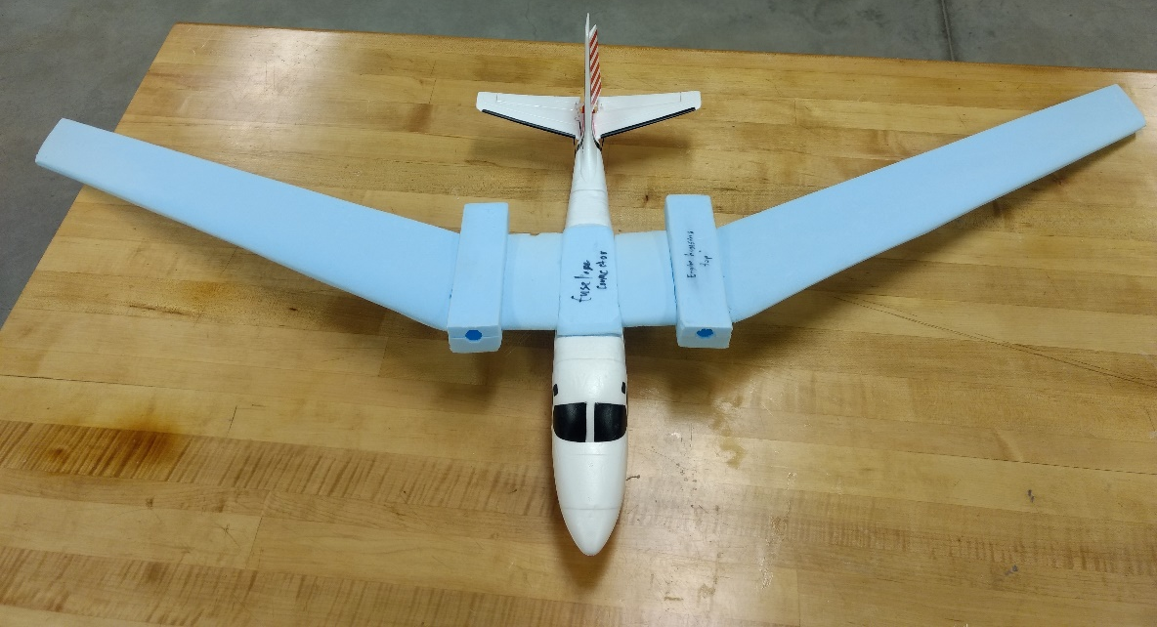
Figure 3: Swept Wing Assembled to RC Plane
Current design constraints are our wind tunnel testing sensors, RC plane motors, and the manufacturability of certain types of foam. Our JR3 PCI board fried before we could program our sensor and couldn’t conduct wind tunnel testing. Currently, the RC plane motors don’t provide enough thrust fly our plane with blue foam wings, and lighter foam options tear more easily.

Long term risks include battery construction, wind tunnel testing, and model aircraft flight. We have developed a battery safety plan. Both wind tunnel and RC plane testing procedures have also been developed.

PRESENTATION SUMMARY
In our presentation, we will start by introducing the executive summary of our project. First, we will show a picture of members of the project. Second, we will introduce our faculty and technical advisers, as well as our project lead and stakeholders. Third, we will show a breakdown of how the project is organized into three separate teams; the Aircraft Design, Battery, and CAD/Build teams. Finally, we will discuss what we have accomplished as a project this semester.

Additionally, we will discuss the activity report of our project. First, we will discuss the milestones that were set earlier in the semester. The Aircraft Design team completed preliminary research into an advanced cooling system and finite element analysis on our designed wings. The Battery team developed a safety procedure outline for problems specific to electric aircraft and a virtual model of our two battery packaging systems. The CAD/Build team completed initial testing and material research and had also wanted to complete wind tunnel testing. Next, we will show a breakdown of how our tasks have been assigned over the course of the semester using JIRA. We will finish the activity report of our project by discussing the health report of our tasks this semester.

Furthermore, we will explain the overview of the project. First, we will talk about what work we have done for our milestones and share the technical details of our work. Then we will discuss some of the items that are constraints of our design.

Similarly, we will discuss our final design. We will do this by discussing the progress that we’ve made and our work for the semester. After discussing our final design, we will talk about the future work that is needed in our project. This section includes some of changes that we have proposed for our design. Furthermore, risks that have been encountered with our design will be explained thoroughly. These include some of the risks that we had planned on, and some of the risks that we encountered that were unexpected. One unexpected risk that we ran into was our JR3 PCI board frying. After discussing our other risks, we will talk about the status of our budget.

To conclude, we will answer any questions that the audience may have. We will also go through our extra slides. These may be helpful in explaining any questions that were not answered during the presentation.

